Sample Software Architecture Documentation

Vehicle control system

Albi Dode
ade15002@student.mdh.se

SAD Revision History

Date | Version | Description | Author
2016-02-05 | 1.1 | Starting the writing | Albi Dode
2016-02-29 | 1.2 | Finalize | Albi Dode

Figure 1. Use cases
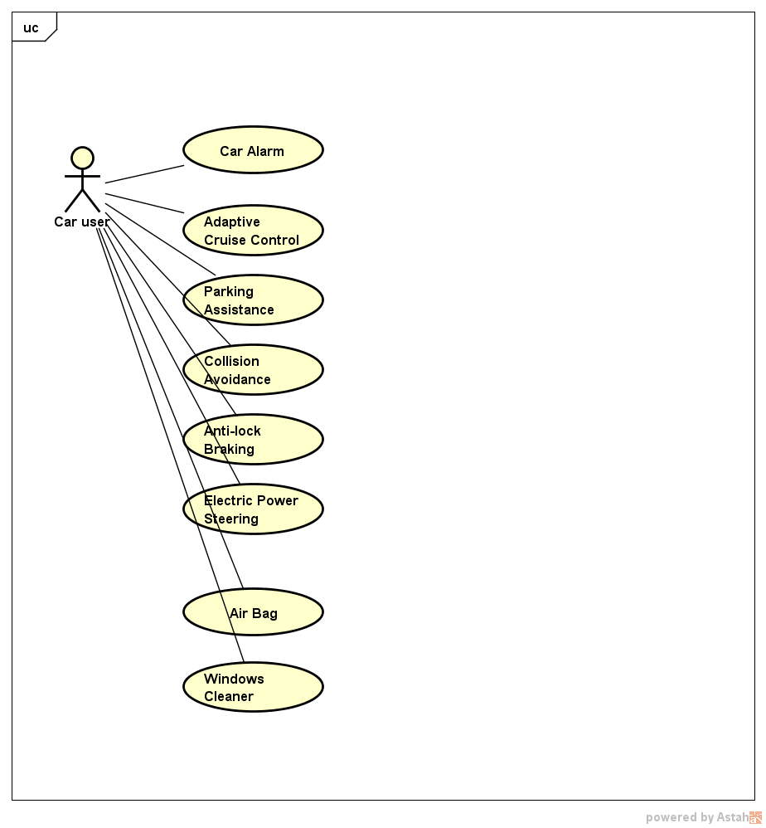

.

Table 1. Functions and Sensors/Actuators relation
Function name | Explain | Sensor;Actuators
Car alarm | Beep if car is being stolen | Motion detection, radio frequencies;siren lock,light
Adaptive Cruise Control | Keep a speed in certain distance | Speed,distance,reflectors,laser;anti-lock,speed control, throtle
Parking Assistente | When parking, when a distance is met it starts beeping | Camera,distance;brake,siren,electric steering,speed boost
Collision avoidance | Avoids collision | GPS,distance,camera;steering,adaptive cruise control
Anti-lock | No lock in brakes | Distance,speed;brake, valves
Electronic Steering | Electic motor help when low speed for car navigation | Position sensor; Hydraulic or electric actuators
Air Bag | Avoid injures | Collision avoidance;valve
Window cleaner | When rain stars, automatically clean it | Rain sensor;windscreen motion

Assignment 2.1
There are different views and for each view different stakeholders have different interest. Also, to be pointed out is the fact that depending on the project or company, stakeholders may vary in number.
Starting with project manager, whose interest towards schedule and resources is bigger than showing interfaces for example. Yet, constraints, environment, interaction arises the interest. So, in general these views will be read carefully:
- Module – as context diagram
- Deployment+Decomposition+Uses - as a layered view
- Work assignment – organization purposes
Development team member, as name suggests, is driven by the given architecture as the whole work process depends on that.
- Decomposition, uses, layered, generalization view – as they need to know what modules are and general relationship
- Concurrency – interaction of components
- Context diagram, interface specification, variability guide – knowing the environment and boundaries.
Testers are the ones that see architecture as a black box. Still, they need information about integration of classes.
- Specifications, uses view are important to them.
- Implementation view – to locate the needed files for the module
- Deployment view – as it addresses issues of installation and performance
- Context diagram, interface specification, variability guide – guide on how to test
Maintainers are the ones that will deal with future changes. So, somehow, they are future developers plus some info more about decomposition view as it will allow them to find the place where to do the change and also a uses view and layered view would be in help as the effects of the changes must be predicted not only by just seeing the design rationale. In short, they are interested in everything.
Application builder is the one who resides in the product line and shapes the aspects of the system by making adaptions.
- Implementation & decomposition/uses view- here the needed artifacts and configuration management and the assembly can be seen.
Customer is the one who pays for the software. Generally their bigger interest is in the progress and costs and in interoperability of the system. For these reasons:
- Work assignment view – how the time was divided on the team members
- Deployment view – to get a general idea of the structure
End user are not much interested in the architecture rather than its functionality. Sometimes they are interested on how to gain the maximum of the system so, they might need:
- Deployment view – for functionality understanding
- Sequence diagrams – how the right usage of the software should be

Time spent on the assignment: Total worked hours for this assignment are those of a half normal working day. After the stakeholders were identified, each of the views were connected to a certain stakeholder while giving a why for that.

Assignment 2.2

- Primary presentation
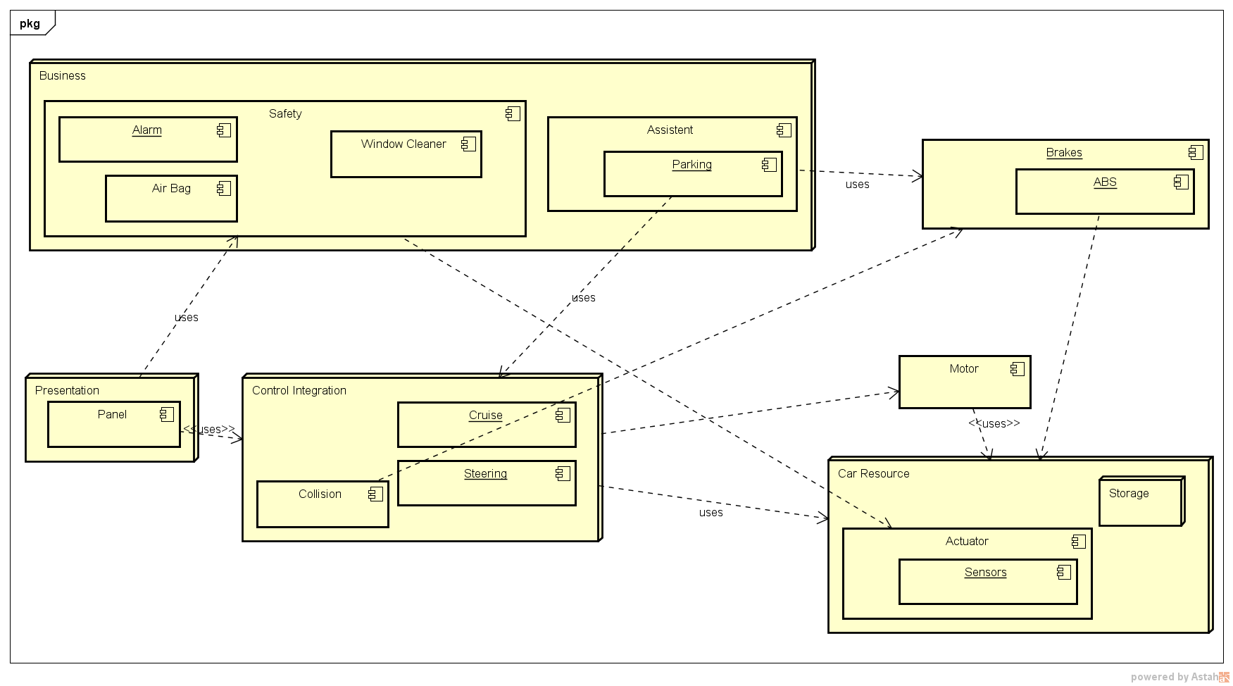

- Element catalogue

Name Property | Responsibility | Implementation | Relation | Elements
Business | Should hold helping functionalities that every model must have.  Alarm- Notify in time  Parking – Help for close distance  Air Bag – Work in time  Cleaner –Easy the view | Alarm – lock + sensor interface. When the sensor trigger is activated, the alarm sounds.  Parking – sensor and distance from camera input. The alarm can be modified by user.  Air bag – hit sensor  Cleaner – sensor triggered | Most of the classes make usage of the sensor and have distance as input. Beside cleaner, others can exchange information among them. | Alarm  Parking  Air Bag  Window Cleaner
Presentation | Panel – As a substitute for the term GUI in a car. | Panel – Appropriately calls the getters from all the other class instances to show info. | Relies on other classes instances. | Panel
Control integration | Cruise & Steering – Helps in driving and keep the right distance | Cruise – its parameters are sensor and speed and are evoked in an appropriate method  Steering & Collision– It can be an extension of cruise | Sensor related. Also motor and brakes instances are present | Cruise  Steering  Collision avoidance
Car resource | Sensor – Gets information and elaborates it appropriately  Storage – Logs the actions | Sensor – getters/setters  Storage – Relies from sensor and stores the info | Crucial for the system | Sensor  Storage
Brakes | Stops or used to keep distance | It can be integrated with cruise control+abs. | Used with cruise and parking | -
Motor | Used to accelerate | Instantiated by user interaction | Cruise instance | -

- Context Diagram
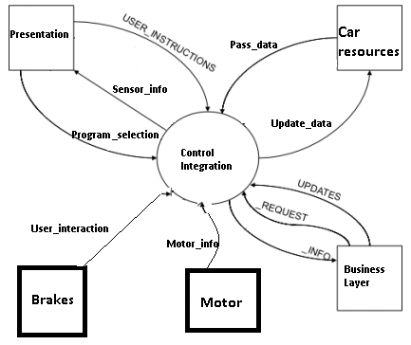

- Variability Guide
As this is a module view we focus on the various versions of parametrization
Business
It is named business as here same basic functionalities of a car reside. Parameters here are predefined or user through the panel can modify only some of them. If variations in functionality may happen in future, they can be in accordance of not depending too much on other modules functionalities.
Control integration
If new functionalities would be required to be added, a redeployment of the system may be required, as here every other module has a relation with it.
Presentation
Here the driver cannot do anything that an admin can do, but still as it is related to the control integration, he/she can modify some parameters from that module. Like the user can select from the menu like the distance that the parking assistant should work and so on with small details. This may require also some changes in the storage.
Storage
All system messages can be stored in the storage system, and there may exist different versions which are self-updated/deleted according to the time or outside interaction. Changing the file where this information is stored: structure or etc. can mean even the redeployment of the system. (This case may happen due to errors not forecasted in the tests, or new requirements).
Brakes
As they reside as an independent module, changes here are welcomed, like changing the parameters value etc., and also a future implementation could be making a further dependency on sensors while parking.
Motor
Again as motor is independent, its functionality is the one that makes the car run. As tale, a motor can be further enhanced or etc., as being a functionality and independent it gives the possibility to further implementations.

- Rationale
This view was chosen as we think it eases the implementation of the vehicle control system. As for a process the code behind resides in the controller. Some pre-installed files in the storage can make the system run even without user input, and still it makes the mapping of classes and events.
While designing we kept in mind the low coupling between sensors and others. Also, we tried to separate sensors from their data usage. This makes possible that the modification that can be made from the sensors outputs can be different and independent from each other. In this way future integrations can be easily done.
Also some rejected alternatives happened as assumptions about the user interaction were needed, and so the design needed to be updated.

Time spent on the assignment: As understanding this assignment was essential even for the understanding of the other assignment, 2 days were enough to make it. Most of the time was spent on trying to understand the variability guide and its connection to this view.

Assignment 2.3
  - Primary presentation
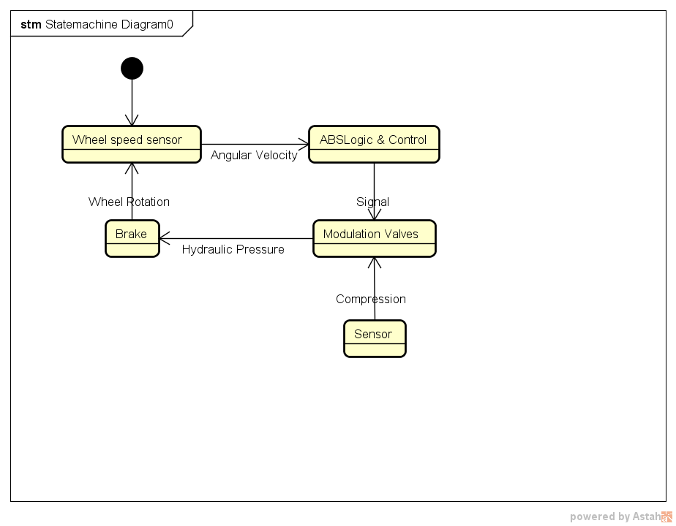
Figure 1. Anti-lock statechart diagram
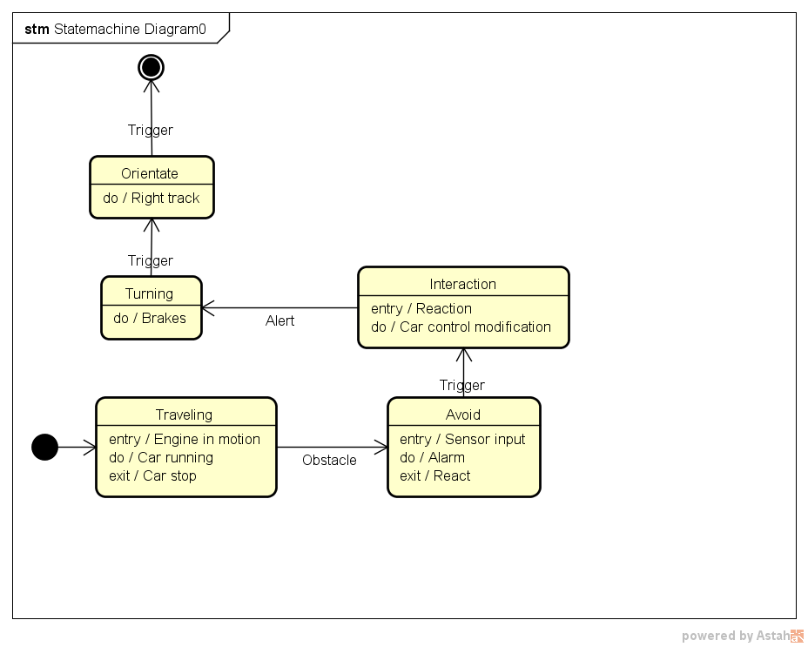
Figure 2. Collision avoidance statechart diagram
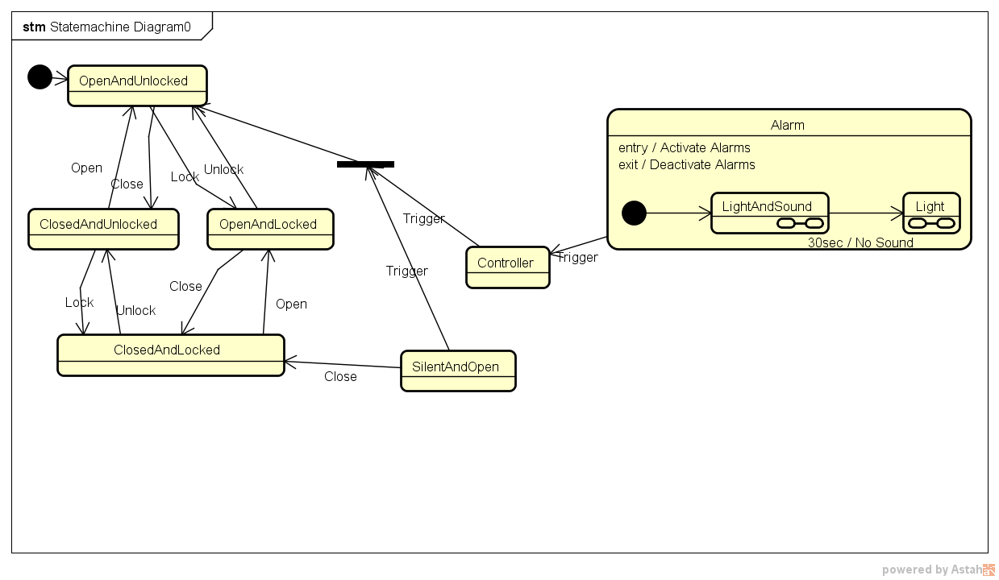
Figure 3. Alarm statechart diagram
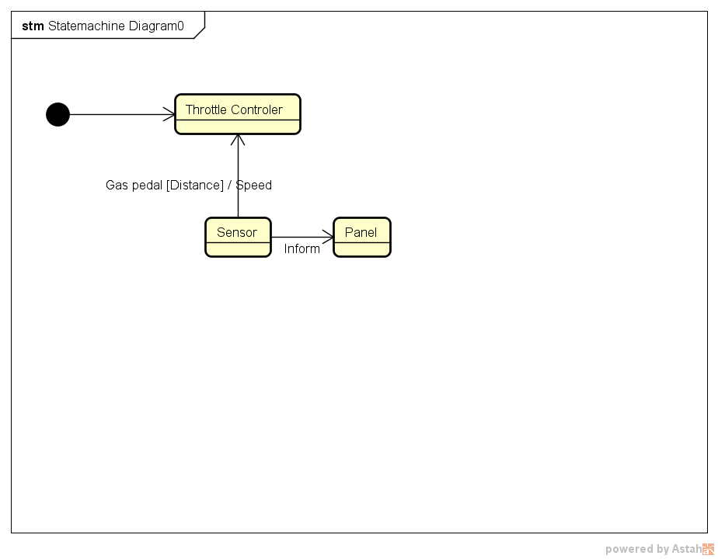
Figure 4. Cruise control statechart diagram
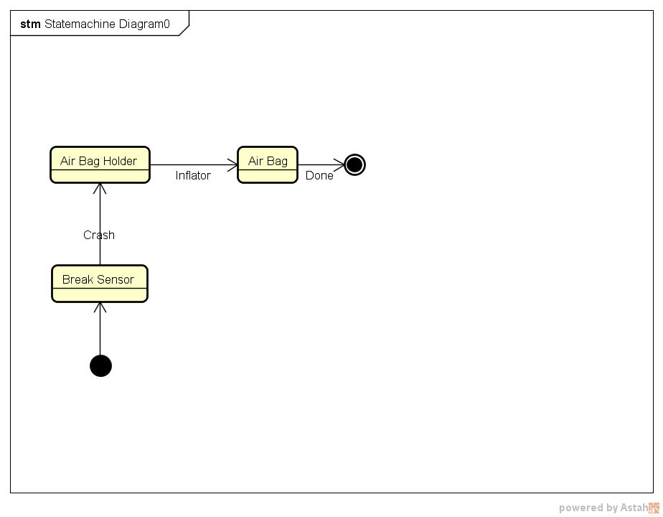
Figure 5. Air bag statechart diagram
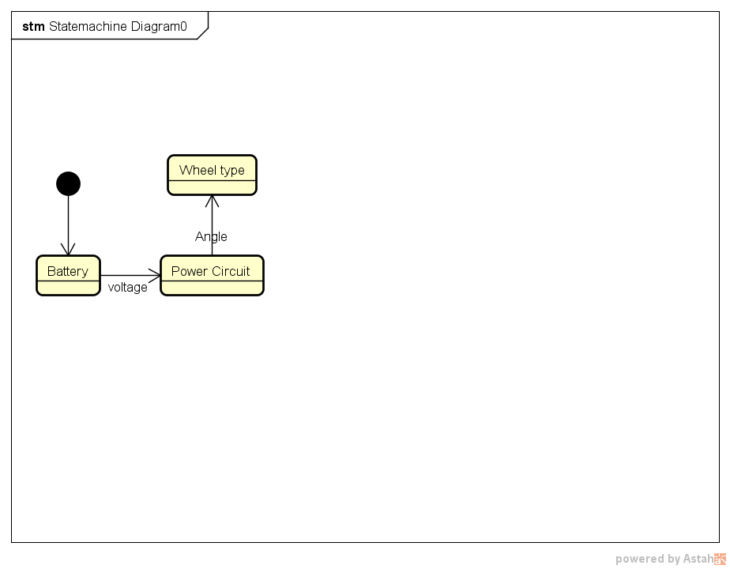
Figure 6. Steering statechart diagram
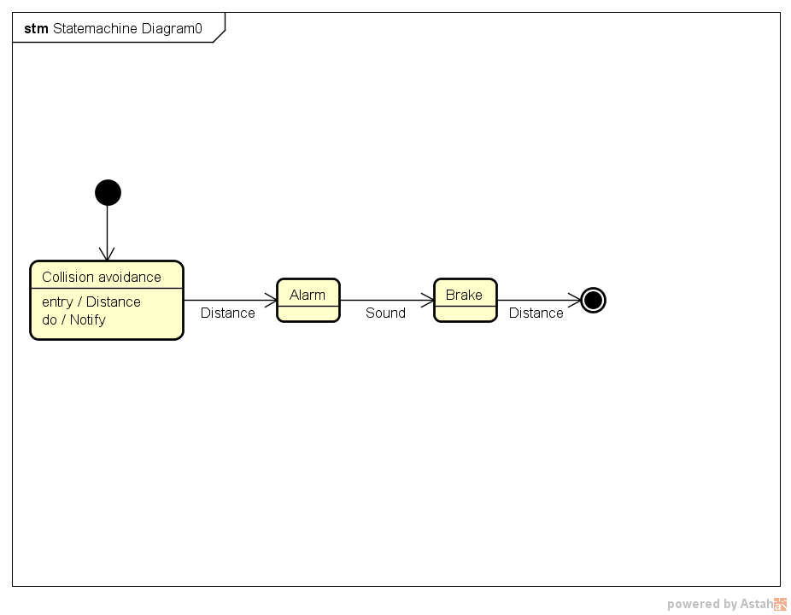
Figure 7. Parking assistant state chart diagram
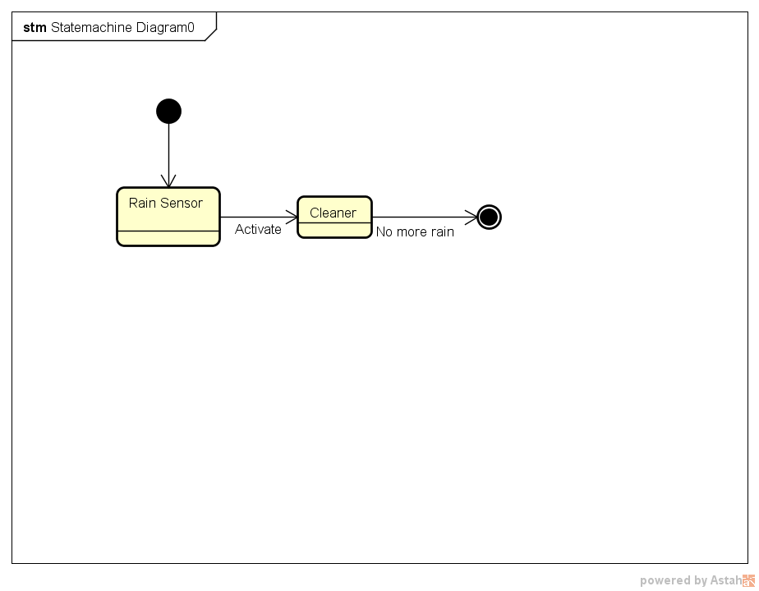
Figure 8. Window cleaner state chart diagram

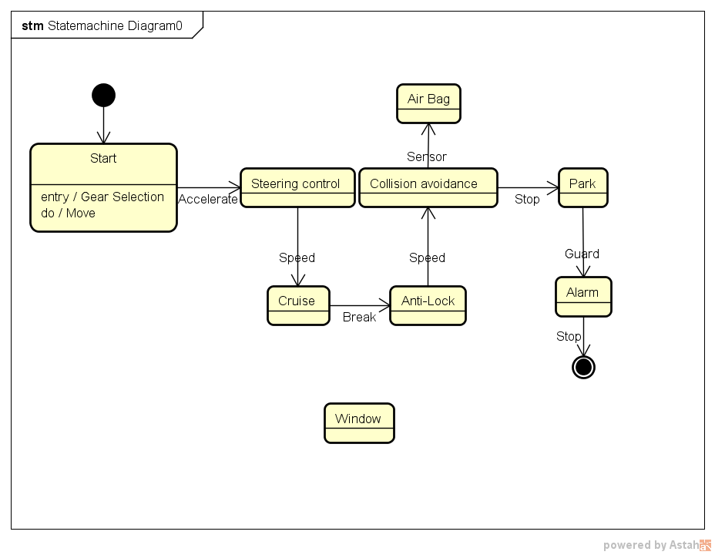
Figure 9. General state chart diagram

  - Element catalogue
Name Property | Responsibility | Implementation | Relation | Elements
Anti-lock | What is needed in order for a car to brake in the right way. | Needs a controller to hold future wheel changes. | runtime | Wheel speed sensor, ABS logic & control, Modulation Valves ,Brake
Collision Avoidance | Whole system reaction on putting the car in the right track for safety reasons. | Brake and steering needs to be modified by these actions. | runtime | Orientate, turning, Interaction, avoid, traveling
Alarm | The connection of doors, sound, lights shows how to secure the car. | Different states should be taken in consideration. | runtime | Status ,light, sound, controller
Air Bag | Under safety measures, it is a necessity. | Sensor and inflator should exchange information | Run time | Break sensor, air bag holder, air bag
Steering wheel | The connection with power sensors to help the car function | Motor and battery are related | Design time | Battery, power, type, controller
Window cleaner | Applying the rain sensor information for safety | Till no more rain, runtime activated | Runtime | Sensor, cleaner
Cruise control | Throttle control for safety as primary | Sensor activated | Build time | Controller, Speed sensor, panel

  - Variability guide
With these state charts diagrams we can see that there are possibilities for different manners to do the same thing. All this depends on the parametrization of the methods. As in this view we in details about the logic of the run time behavior, this will be also our focus: constraints and requirements. In some cases this means more maintenance and parallel versions.
Name/Variation point | Options | Binding time- How it is done
Alarm/personalization | Some user personalization can make variations with including like door lock and different sounds and lights. | Safety critical elements grouped and separated during development (design time).  Relation with other modules like ignition system (not in this view) for example may lead to non-predicted behavior.
Cruise/throttle | User can go till a certain speed – constraint control | To be done at build time.
Collision/Distance | User can modify the distance till a certain value – constraint control | To be done at build time.
Parking/alarm | Sound or not | At running time.
Anti-lock | Sensor information about wheel speed and brakes condition will be the main input variables, as this is in accordance with the ABS algorithm. Changes or tests here will be changed according to particular platform and can be treated as timing values (how fast the new system will react). It will be applied to each wheel in parallel. | Design time.
Steering/Wheel type | The integration with the wheels type should be considered in the parameter type. It should be properly correlated with other duties. | Runtime
Air Bag/Sensor +inflator | Always active | Runtime

    - Rationale
We use state chart diagram as a way to describe how a system behaves as we can get some information on the dynamic behavior and events. The events predicted to occur in different states are shown as a diagram that has classes and different states in which its objects may be. The representation can be similar to that of a finite state machine as it illustrates how the behavior evolves. We decided to go in this way as it is easier to answer questions such as:
- Forward and reverse engineering.
- What events to use in order to achieve a state
- Object-event relation
- Responding to an event for an object
The other why behind this diagram is to show the changes of states as imposed by events which can either be internal or external factors. Programmers need to know the states of the class objects and their identification makes the implementation easier. As for the assumptions we can say that this diagram has to be seen in two ways: as a sequence and as independent. This is why we included two versions, as the user may use the car as a normal driving vehicle and also just some of its functionalities. The possible states that the classes and their respective events makes that the transitions somehow show the lifecycle of that class.
Runtime behavior
The behavior of a state, bindings, the times a method is called or a variable is accessed can be seen in the run time. Going with this path, we can try to allocate anomalies and it can be a good starting point for testing. We can also think of the presentation panel as an information collector, and according to later future objectives, it interprets them, also based on subcomponents that are important in the decision making it as a controller.
When the classes’ instances and methods will be running, they will be coded in such a way that modifying the default behavior should be easy. This can be achieved may be by adding a method that binds parameters (among classes) a dispatcher and a validator.

Time spent on the assignment: 1.5 day was spent as it required more UML work and the template of the assignment 2 has to be seen from a different prospective.

